

Dynamics 365 Government Accelerator

Walkthrough Guide

Published: July 21, 2022

Accelerator Release Version: 1.0.3.0

File Name: Government.Acelerator.Walkthrough.Guide.docx

# 

Table of Contents

Introduction 3

Installing the Government Accelerator 4

Dependencies 4

Option 1 4

Option 2. 4

Accelerator Walkthrough 5

Personas 5

Connection Roles 5

What’s included in the Government Accelerator? 5

Sample End-to-End Workflows 6

Resident and Business Portal 6

Application Approval 10

Dashboard 12

Government CDM Entity References 13

Organizations 13

Government Services and Programs 14

Program Example 15

Service Example 16

Grants, License and Permits 17

Requests 17

Additional Resources 18

# Introduction

Government organizations are progressively turning to data to address their most pressing challenges, yet many struggle to unlock the value of their data due to highly fragmented data states that hinder their digital transformation. Implementing the Government Common Data Model (CDM) helps agencies eliminate data silos that enable power insights to take actions on their own data and help advance their mission in the areas of in the areas of public finance, public health & social services, public safety & justice, and critical infrastructure.

The government data model included in this first release supports use cases centered around government policy, services, programs, benefits, eligibility, licenses, permits, grants and more. This standardized data blueprint improves interoperability by unifying and shaping the data in a consistent form that can be easily used across government applications, processes, and workflows in Power Platform, Dynamics 365, and across the Microsoft technology stack. With a shared understanding of the data, partners and developers can use these data elements to accelerate their time to value and deliver mission-focused solutions for government agencies.

This documentation provides a walkthrough of the key dashboards, apps, flows and portal within the Government Accelerator offering.

# Installing the Government Accelerator

There are two options to deploy the Government Accelerator.

## Dependencies

Before deploying the Government Accelerator, please make sure to have an environment with **Power Apps** and a blank **Power Apps Portal** provisioned. To create a blank portal please follow instructions in 4.1 of the [Installation Guide.](https://view.officeapps.live.com/op/view.aspx?src=https%3A%2F%2Fraw.githubusercontent.com%2Fmicrosoft%2FIndustry-Accelerator-Government%2Fmain%2Fdocumentation%2FGovernment.Accelerator.Installation.Guide.docx&wdOrigin=BROWSELINK)

**Note**: if deployment is in a Government Community Cloud (GCC) environment, please follow Option 2 below.

Option 1**.** Visit [AppSource](https://appsource.microsoft.com/en-US/product/web-apps/msgov.govsolution?tab=Overview).

Select **Get It Now**. Then check **Add all Government Accelerator** and click on **Deploy**.

Once deployment is successfully completed, follow the “Post-deployment: Configure your portal” [**here.**](https://docs.microsoft.com/en-us/dynamics365/industry/accelerators/government-configure)

Option 2. Using Package Deployer.

Follow the steps in this [Installation Guide.](https://view.officeapps.live.com/op/view.aspx?src=https%3A%2F%2Fraw.githubusercontent.com%2Fmicrosoft%2FIndustry-Accelerator-Government%2Fmain%2Fdocumentation%2FGovernment.Accelerator.Installation.Guide.docx&wdOrigin=BROWSELINK)

# Accelerator Walkthrough

## Personas

The walkthrough document was created with the following Personas in mind:

1. **Resident** – A person living in a community controlled by a local, state, or federal government.
2. **Government Employee** – A person employed by a local, state, or federal government.
3. **Reviewer** – A person that works for a government whose responsibilities include reviewing applications for grants, licenses, or permits.
4. **Program Administrator** – A public office employee who oversees government programs or services.

## Connection Roles

Connections allow connecting records with other entities' records with no need to customize or create custom relationships. Included with the government accelerator are the following connection roles:

### Service to Contact

1. Government Service

Program to Contact

1. Government Program

### Contact to Service

1. Service Manager
2. Service Deputy
3. Service Agent

### Contact to Program

1. Program Director
2. Program Manager
3. Program Coordinator

## What’s included in the Government Accelerator?

In addition to the data model, this first release of the government accelerator includes a sample app experience, a sample portal and sample data. The portal is a customizable Power Apps portal for residents and businesses to apply for government services, programs, and benefits. The app is a customizable Power App for government services, programs, and benefits to manage applications, approvals, and transform government programs and services.

# Sample End-to-End Workflows

## Resident and Business Portal

The government accelerator includes a customizable Power Portal for residents and businesses to apply for government services.

1. Navigate to Contoso County Sample portal by typing the “Primary Domain Name” URL for your portal environment in a new browser tab.
   1. Address can be found in Portal Management App à Government Services Portal à General, next to Primary Domain Name
2. The portal’s homepage displays several options that are currently available for exploring in the areas of businesses, licenses, permits, and housing.
   1. Future releases of the Government Accelerators will enhance the data model within the existing areas and expand to cover additional use cases.
3. For the following example we will use Contoso County’s resident Lilly Conner
4. After landing on the homepage, Lilly goes to the sign-in page by clicking **sign in** on the right side of the top ribbon

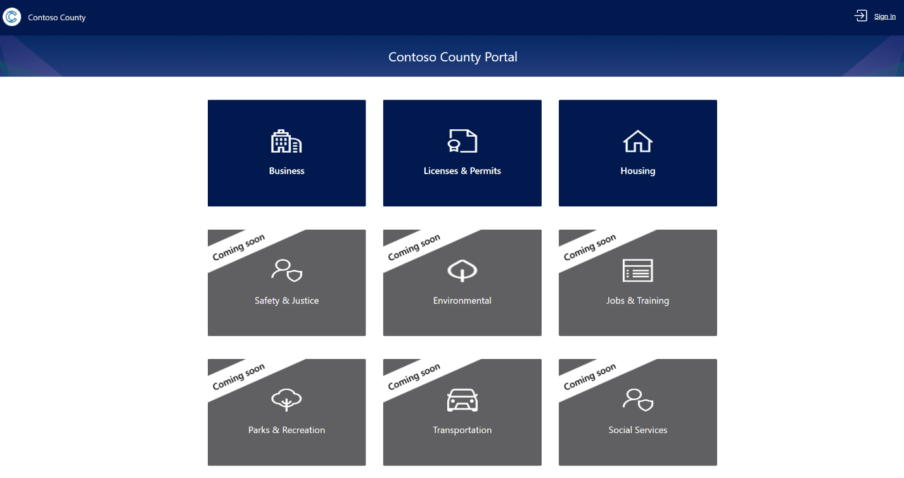

1. Lily proceeds to sign in by authenticating with Azure AD.

1. Once sign-in is complete, Lily can verify her profile by seeing her name on the top right.
2. Lily was furloughed due to Covid-19 and needs financial help to pay rent. On the Contoso County homepage, she clicks **Housing** and is re-directed to another site where she can browse the different options within housing to apply for rent aid.



1. Lily finds “get help for housing assistance” and clicks on **Learn More.** In the next page she clicks on **Learn More** under “Eviction Prevention and Rent Assistance Program”.
2. A banner appears on screen displaying the program’s mission statement and eligibility requirements. To proceed click **Next.**

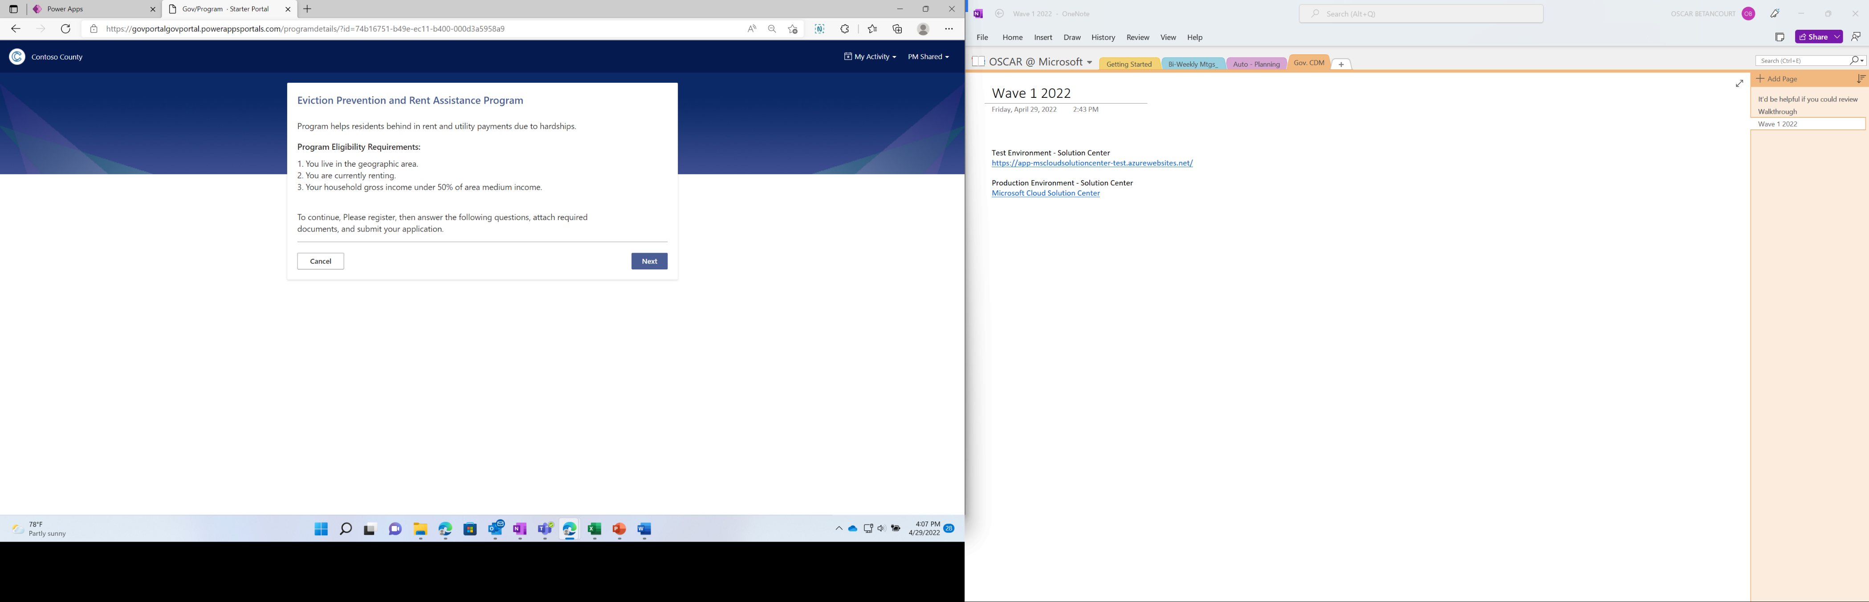

1. The following page is a questionnaire for Lily to add her contact information. Click **Next** to proceed with the questionnaire.

1. Information about applicant’s eligibility is gathered including supporting documents to validate the eligibility such as: employer furlough letter, previous tax returns, pay stubs, rental agreement, etc. The application can be completed by clicking **Apply** in the form and then **OK** in the pop-up window.

1. Lily wants to make sure the application was successfully submitted so she heads to **My Applications** found in the top ribbon on the right side and is then able to see the application recently submitted.

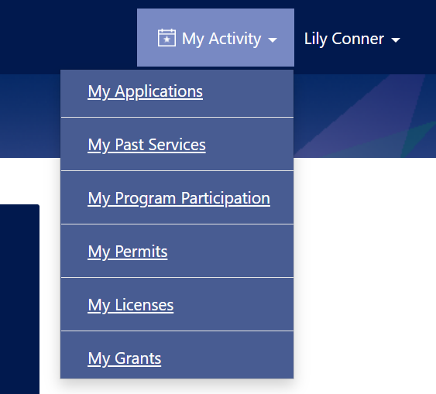

## Application Approval

1. After Lily Conner submitted her application, the Active Applications view in the Government Services Sample App gets updated to show a NEW application submitted.

1. The reviewer opens the application by clicking on the **Subject** text of the record. All the details about the application are displayed.

1. The reviewer will continue to take the application through the different stages by clicking on the **Stage Name**, inputting his selection in the prompted fields, and clicking **Next Stage** button. Note: workflows are fully customizable to add or delete steps as well as automation.

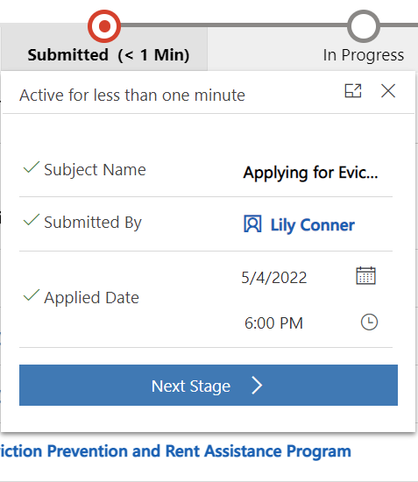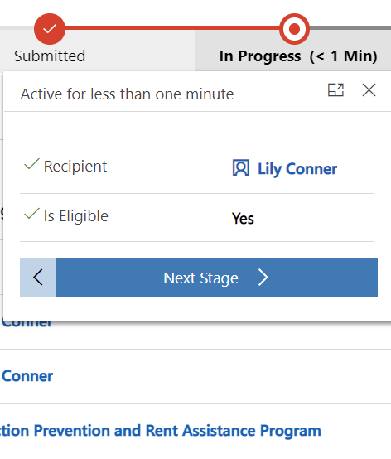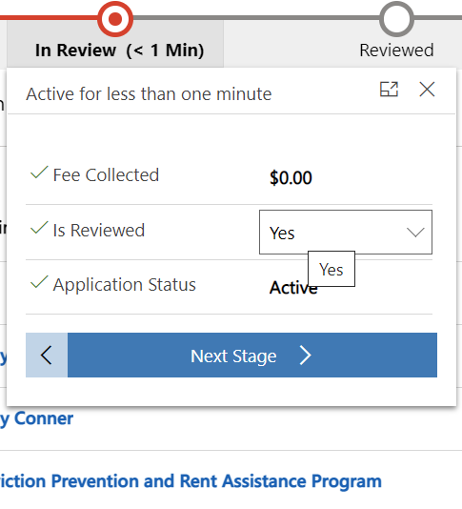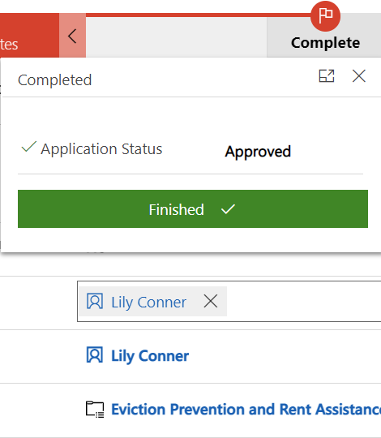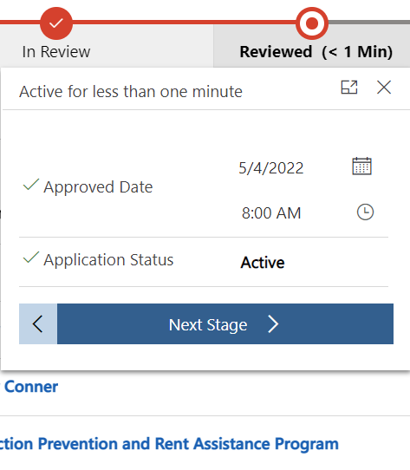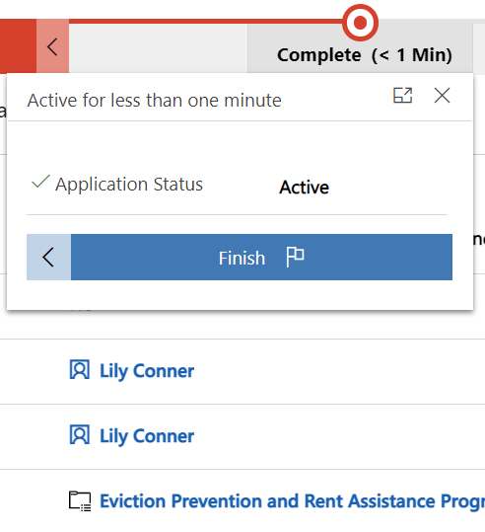

1. Upon completing the review, Lily’s application was approved, and the new status is also displayed in the Contoso County portal for Lily to view



## Dashboard

The government services sample app also includes two provisioned dashboards that allow a government employee or program owner to quickly get high level information on the applications for their programs and services.

# Government CDM Entity References

## Organizations

The Government Accelerator uses the standard entities from the Common Data Model (CDM) to host information about departments and organizations within the public sector, their constituents, and surrounding businesses that make up a community.

### Table Description automatically generated with low confidenceGovernment Organizations

Any department within the public sector that deals with controlling or regulating a nation, organization, or people.

### Public Policies

A plan of action to guide decisions and actions. New entity created for the Government Accelerator.

### Businesses

An entity that seeks to profit from a product or service.

### Residents

A person that lives in a community

## Government Services and Programs

The Government Accelerator has an extensible model for Government Services and Programs which include:

### Graphical user interface, application Description automatically generated with medium confidenceServices

Services are activities performed by government for the benefit of the general population.

### Service Types

A categorization of services based upon common attributes, characteristics, strategies or functions performed.

### Programs

Government programs are created, staffed and funded to provide program benefits to program participants. Programs require fulfillment of eligibility requirements, formal participation and acknowledgement of participating in the program.

### Program Type

A categorization of government programs based upon common attributes, characteristics, strategies or functions performed.

### Program Benefits

A benefit provided or offered in conjunction with the associated program.

### Eligibility Requirements

An eligibility Requirement(s) associated with the program.

## Program Example

1. Click on **Program** in the left pane to see all the active services.
   1. Each program needs to have a name, be tied to a **government organization** within the system, have an **introduction date** and **service status.**
   2. To see details on any specific program, simply click on the program’s name
2. A **Program** **Benefits** must be associated with a **program** andneeds to have a **name**, **period start date,** and **period end date** for the record to exist.
3. While not always required, one can create **Eligibility Requirement** as a criteria for approving program applications.
4. Click on **Program**, then on **Business Recovery Program** recordnameto see the sample program below.

## Service Example

1. Click on **Services** in the left pane to see all the active services.
   1. Each service needs to be tied to a government organization within the system and have an **introduction date** and **service status.**
   2. To see details on any specific service, simply click on the service’s name.
2. Click on **Apply for Building Permit** record name to see sample record below.

## Grants, License and Permits

The Government Accelerator includes an extensible model for grants, license and permits.

### Table Description automatically generated with medium confidenceGrants

An award of financial assistance from a government agency to a recipient to fund ideas and projects to provide public services and stimulate the economy.

### License

A license is granted by a government or regulating agency to do something or use something.

### Permits

A permit is an official city document that allows a party to do something or have something.

## Requests

The Government Accelerator includes an extensible model for processing and tracking program and service requests which includes the following:

### Text Description automatically generated with medium confidenceApplications

A request submitted by an individual or business for a government service or benefit.

### Application Types

A categorization of government applications based upon common attributes, characteristics, strategies or functions performed.

### Service Recipients

An individual or legal entity that is a participant, prospective participant or recipient of a service or program.

### Program Recipients

A recipient that has a relationship with the program over the indicated period.

# Additional Resources

* Additional resources about Microsoft Industry Accelerators can be found on [Microsoft Docs](https://docs.microsoft.com/en-us/dynamics365/industry/accelerators/overview).
* Specific references for the Government Accelerator can be found [here](https://docs.microsoft.com/en-us/dynamics365/industry/accelerators/government-overview) and on [AppSource](https://appsource.microsoft.com/en-US/product/web-apps/msgov.govsolution?tab=Overview).
* To learn more about extending the Government CDM click  [here.](https://github.com/microsoft/Industry-Accelerator-Government/blob/main/documentation/Admin%20Guide%20-%20Creating%20Custom%20Application%20Types.docx)